|Roll no:CB.EN.U4CSE18243
Name:Yaswanthram Ponnada

1. Create the following tables
- Customer Master Table: cust
Attribute Name | Data Type | Constraints
custid | varchar2(3) | Primary Key ,not null
Lname | Varchar2(15)
Fname | Varchar2(15)
area | Varchar2(2)
phoneno | Number(8)

- Movies Master Table: movie
Attribute Name | Data Type | Constraints
Mvno | Number(2) | Primary Key ,not null
title | Varchar2(25)
type | Varchar2(10)
star | Varchar2(25)
price | Number(8,2)

- Invoice transaction Table : invo
Attribute Name | Data Type | Constraints
Invno | Varchar2(3) | Primary Key ,not null
mvno | Number(2) | Foreign key movie(mvno)
custid | Varchar2(3) | Foreign key cust(custid)
star | Varchar2(25)
price | Number(8,2)

- Insert the following data into the tables created
Table:Cust
custid | Lname | Fname | Area | PhoneNo
A01 | Bayross | Ivan | sa | 6125467
A02 | Saitwal | Vandana | mu | 5560379
A03 | Jaguste | Pramada | da | 4563891
A04 | Navindgi | Basu | ba | 6125401
A05 | Sreedhar | Ravi | va
A06 |  | Rukmini | gh | 5125274

Table:Movie
mvno | Title | type | star | price
1 | Bloody Vengeance | action | Jackie Chan | 100.00
2 | The Firm | thriller | Tom cruise | 200.00
3 | Pretty Woman | romance | Richard Gere | 150.00
4 | Home Alone | Comedy | Macaulay Culkin | 150.55
5 | The Fugitive | Thriller | Harrison Ford | 200.00
6 | Coma | Suspense | Michael Douglas | 100.00
7 | Dracula | Horror | Gary Oldman | 150.25
8 | Quick change | Comedy | Bill Murray | 100.00
9 | Gone with the wind | Drama | Clarke Gable | 200.00
10 | Carry on Doctor | Comedy | Leslie Phillips | 100.00

Table:Invo
invno | Mvno | custid | issueDate | retDate
i01 | 4 | A01 | 23-jul-93 | 25-jul-93
I02 | 3 | A02 | 12-aug-93 | 15-aug-93
I03 | 1 | A02 | 15-aug-93 | 18-aug-93
I04 | 6 | A03 | 10-sep-93 | 13-sep-93
I05 | 7 | A04 | 05-aug-93 | 08-aug-93
I06 | 2 | A06 | 18-sep-93 | 20-sep-93
I07 | 9 | A05 | 07-jul-93 | 10-jul-93
I08 | 9 | A01 | 11-aug-93 | 14-aug-93
I09 | 5 | A03 | 06-jul-93 | 09-jul-93
I10 | 8 | A06 | 03-sep-93 | 06-sep-93

3. Write Query statements for the following

Single Table Retrieval
I., Find out the names of all title customers.

SELECT Fname, Lname from Cust1

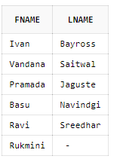
2. Print the entire customer table.

SELECT * FROM Cust1;

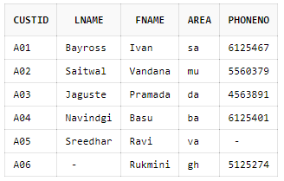
- Retrieve the list of fname and the area of all the customers.

SELECT Fname,Area from Cust1;

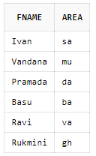
- List the various movie types available from the movie title

SELECT title,movietype FROM Movie1
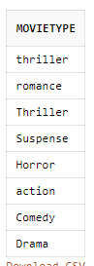
- Find the names of all customers having 'a' in the second letter in their fname
SELECT fname FROM Cust1 WHERE SUBSTR(fname,2,1) = 'a'
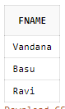

- Find the Lname of all customers that begin with 's' or T.

SELECT * FROM Cust1 WHERE
Lname like 'S%'
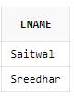

- Find out the customers who stay in an area whose second letter is ‘a'.
SELECT fname FROM Cust1 WHERE SUBSTR(Area,2,1) = 'a'

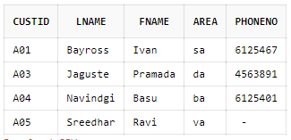
- Find the List of all customers who stay in area 'fa’ or area °mu' or area 'gh".

SELECT Fname FROM Cust1
WHERE Area IN ('fa', 'mu', 'gh')
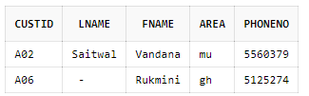
- Print the list of customers whose phone 'numbers are greater than the value 5550000. '

SELECT Fname FROM Cust1
WHERE Phoneno > 5550000
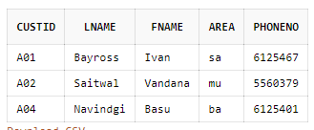
- Print the information from invoice table of customers who have been issued movies in the month of september.

select * from Invo where issueDate like '%sep%';
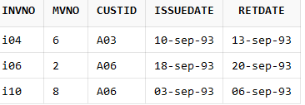

- Display the invoice table information for custid 'A01' and 'A02'.

select * from Invo where custid='A01' or custid='A02';
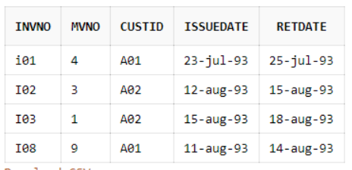
12. Find the movies of type 'action" and "comedy'.

SELECT title FROM Movie1
WHERE movietype IN ('action','comedy')

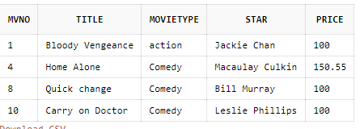
13. Find the movies whose price is greater than 150 and less than or equal to 200.

SELECT title FROM Movie1
WHERE price BETWEEN 150 AND 200
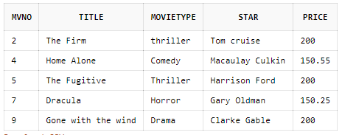
14. Find the movies that cost more than 159 and also find the new cost as original cost* 15

select Mvno,title,movieType,star,price *15 from movie where price > 159 ;
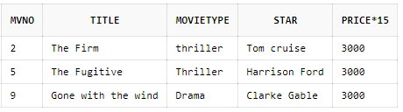
15. Rename the new column in the above query as new price,

select Mvno,title,movieType,star,price *15 as "newprice" from movie where price > 159 ;
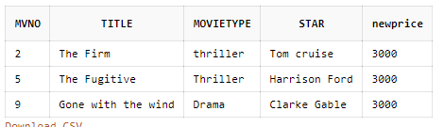
16. List the movies in sorted order of their titles.

select * from movie order by title ;
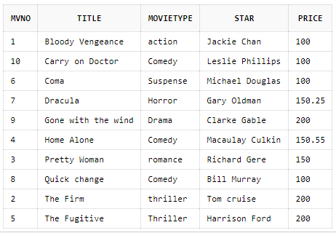
17. Print the names and types of all the movie except horror movies.

select title,movietype from movie where movietype not like 'horror';
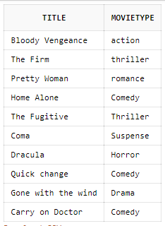

18. Calculate the square root of price of each movie.

SELECT TITLE,SQRT(PRICE) FROM MOVIE;
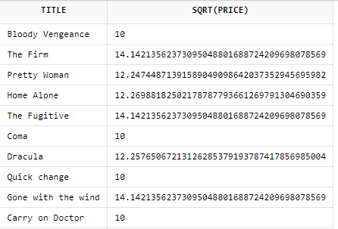
19. Divide the cost of movie "home alone’ by difference between its price and 100 .

select title,(price/(price-100)) as "new price" from movie where title='Home Alone'
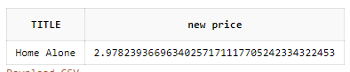
20. List the names. areas and custid of customers without phone numbers.

select Fname,Lname,area,custid from cust where Phoneno is null
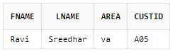
21. List the names of customers without Lname.

select Fname from cust where Lname is NULL
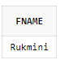
22. List the myno, title, type of movies whose stars begin with letter m.

select mvno,title,movietype from Movie where star like 'M%';
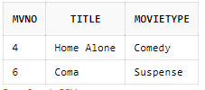
23. List the mvno and invno of customers having jnvno less than °i05" from the Invoice Transaction table.
select mvno, invno from invo where invno like 'i01' or invno like 'i02'or invno like 'i03' or invno like 'i04';
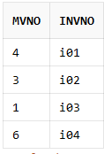
Set function and concatenation:
24. Count the total number of customers.
SELECT COUNT(*) FROM CUST1
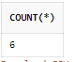
25. Calculate the total price of all the movies.
SELECT SUM(PRICE) FROM MOVIE1;
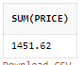
26. Calculate the average price of all the movies.
SELECT SUM(PRICE) FROM MOVIE1;
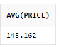
27. Determine the maximum and minimum of prices. Rename the title as max_price and min_price respectively.
SELECT MAX(PRICE)as MAX_PRICE FROM MOVIE1;
SELECT MIN(PRICE)as MIN_PRICE FROM MOVIE1;
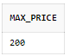
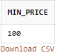
28. Count the number of movies having price greater than or equal to 150.
SELECT COUNT(PRICE) FROM MOVIE1 WHERE PRICE>=150;
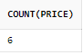
29. Print the information of invoice table in the following format for all records
A} The Invoice No. of Customer Id. {custjd} is {inv_no} and Movie No. is {mv_no}. .
,B} {custJd} has taken Movie No. {mv_no} on {issue_date} and ,will
return on {return_date}.

Having and Group By
30. Print the type and average price of each movie
31. Find the number of movies in each type
32. Count separately the number of movies in the 'comedy' and 'thriller' type.
33. Calculate the average price for each type that has a maximum price of 150,00. -
34 Calculate the average price of all movies where type is comedy' or "thriller' and price is greater than or equal to 50

Table Updations:
- Change the telephone number of pramada to 466389.
- Change the issueDate of custid 'A01' to 24/07/93.
- Change the price of 'gone with the wind' to Rs. 250.00.
- De!ete the record with invoice number 'i05' from the invoice table.
- .Delete all the records having return date before 10th July '93
- Change the area of custid a05 to ‘vs’.

